**Ex.no: Date:**

**Flex properties**

**Aim:**

To create a simple webpage using flex and its and properties

**Program:**

<!DOCTYPE html>

<html>

<head>

<meta name="viewport" content="width=device-width, initial-scale=1.0">

<link rel="stylesheet" href="style.css">

<title>Flex</title>

</head>

<body>

<div class="header">

<h3 id="header">Movies Mania🎥</h3>

</div>

<div class="topnav">

<a class="active" href="#home">Home</a>

<a href="#news">Now Showing</a>

<a href="#contact">Upcoming movies</a>

<a href="#about">About</a>

</div>

<div class="container1">

<div class="flex1">

<img src="demon.jpg" class="img1">

</div>

<div class="content1">

<h3>Demon Slayer</h3>

<h4>Demon Slayer: Kimetsu no Yaiba is a popular manga and anime series written by Koyoharu Gotouge. The story follows Tanjiro Kamado, a young boy who becomes a demon slayer after his family is brutally attacked by demons, and his sister Nezuko, who has been turned into a demon.</h4>

<p>The series explores Tanjiro's journey to seek revenge for his family and find a cure for his sister. Along the way, he joins forces with other skilled demon slayers and encounters powerful demons.</p>

</div>

</div>

<div class="container2">

<div class="content2">

<h3>DragonBall</h3>

<h4>Dragon Ball is a popular Japanese manga and anime series created by Akira Toriyama. The story follows Goku, a Saiyan warrior, as he embarks on various adventures to protect the Earth from powerful villains and search for the Dragon Balls, magical orbs that can grant wishes when gathered together.</h4>

<p>Throughout the series, Goku trains and becomes stronger, forming powerful friendships and rivalries along the way. Dragon Ball has multiple sagas, including Dragon Ball, Dragon Ball Z, Dragon Ball GT, and Dragon Ball Super, each continuing the epic story of Goku and his allies.</p>

</div>

<div class="flex2">

<img src="goku1.jpg" class="img2">

</div>

</div>

<div class="display">

<img src="jujutsu.jpg" id="img1">

<img src="naruto.jpeg" id="img2">

<img src="onepiece.jpg" id="img3">

</div>

</body>

</html>

body{

font-family: Arial, Helvetica, sans-serif;

background-color: darkolivegreen;

}

.topnav{

overflow: hidden;

background-color: #333;

}

.topnav a {

float: left;

color: #f2f2f2;

text-align: center;

padding: 14px 16px;

text-decoration: none;

font-size: 17px;

}

.topnav a:hover {

background-color: #ddd;

color: black;

}

.topnav a.active {

background-color: #0470aa;

color: white;

}

.header{

background-color: #0470aa;

padding-top: 5px;

padding-bottom: 5px;

margin-bottom: 6px;

}

#header{

color: white;

text-align: center;

font-family:Arial, Helvetica, sans-serif;

font-style:italic;

}

.container1{

margin-top: 6px;

display: flex;

background-color: rgb(233, 219, 203);

width: auto;

height:575px;

}

.flex1{

columns: 1;

padding: 10px;

}

.container2{

margin-top: 6px;

display: flex;

background-color: rgb(233, 219, 203);

width: auto;

padding-left: 10px;

}

.flex2{

columns: 1;

padding: 10px;

}

.container2 img{

height: 550px;

margin-left: 285px;

margin-top:4px;

margin-bottom: 4px;

margin-right: 4px;

}

.display{

margin-top: 5px;

display: flex;

background-color: rgb(233, 219, 203);

height: fit-content;

flex-direction:row;

}

#img1{

width: 460px;

margin-left: 30px;

margin-top: 10px;

margin-bottom: 10px;

}

#img2{

width: 460px;

margin-left: 30px;

margin-top: 10px;

margin-bottom: 10px;

}

#img3{

width: 460px;

margin-left: 30px;

margin-top: 10px;

margin-bottom: 10px;

margin-right: 10px;

}

h4:hover{

background-color: black;

color: white;;

}

**Output:**

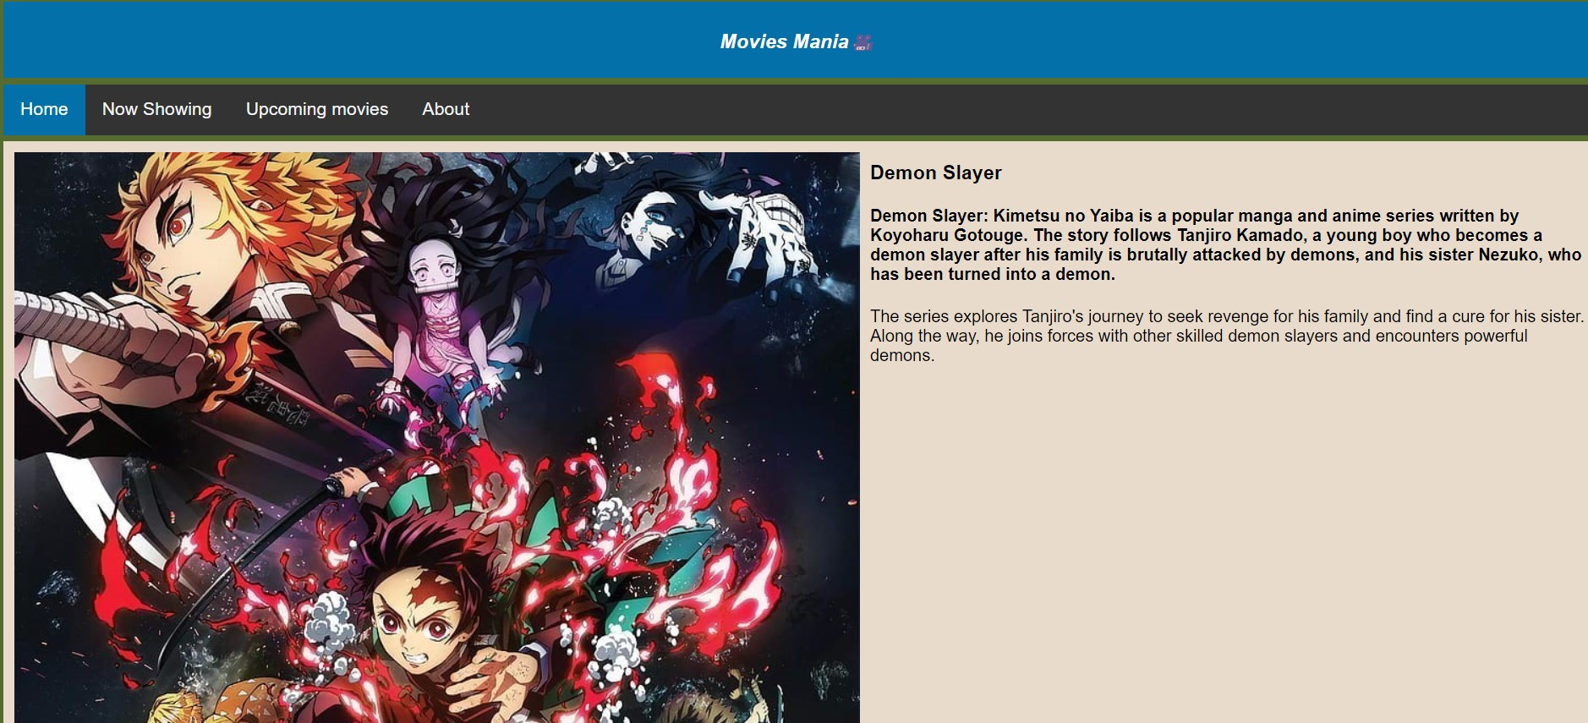

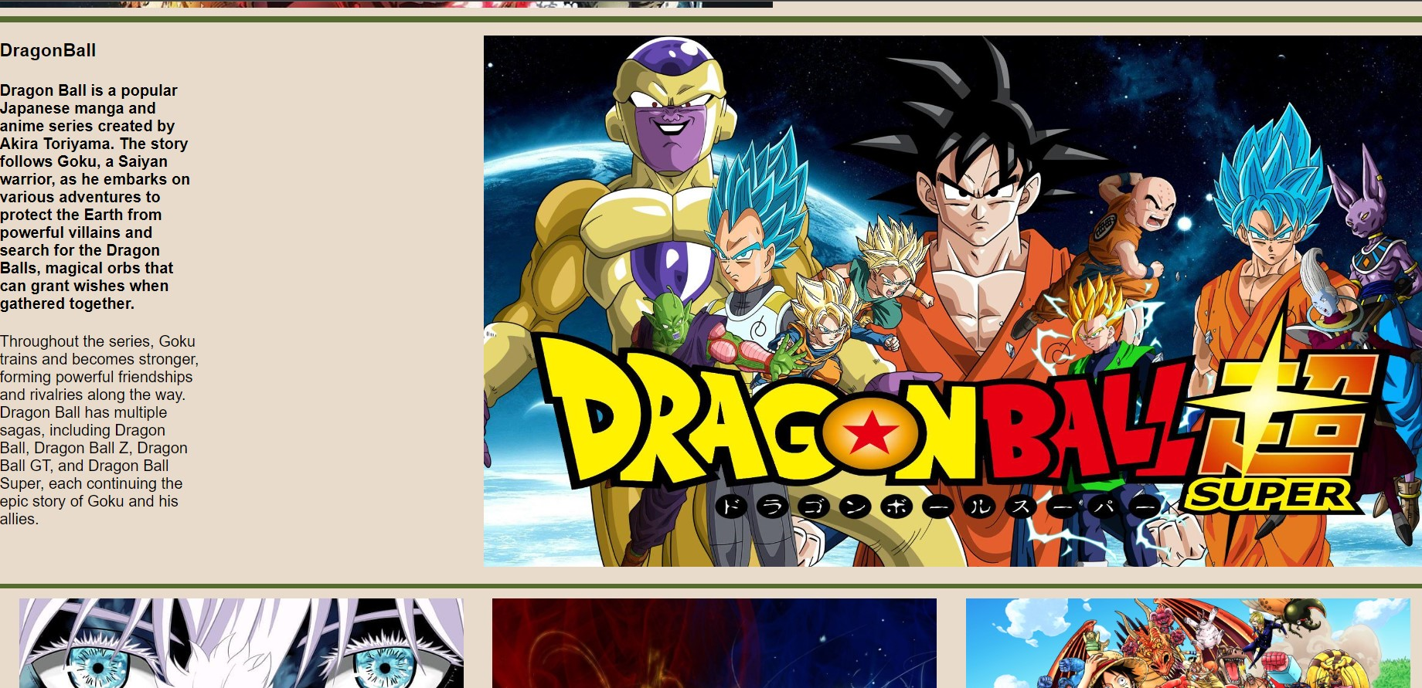

|  |  |
| --- | --- |
| **Class performance** |  |
| **Viva** |  |
| **Record** |  |
| **Total** |  |

**Result:**

Thus the flex and its properties have been implemented successfully and output is verified.